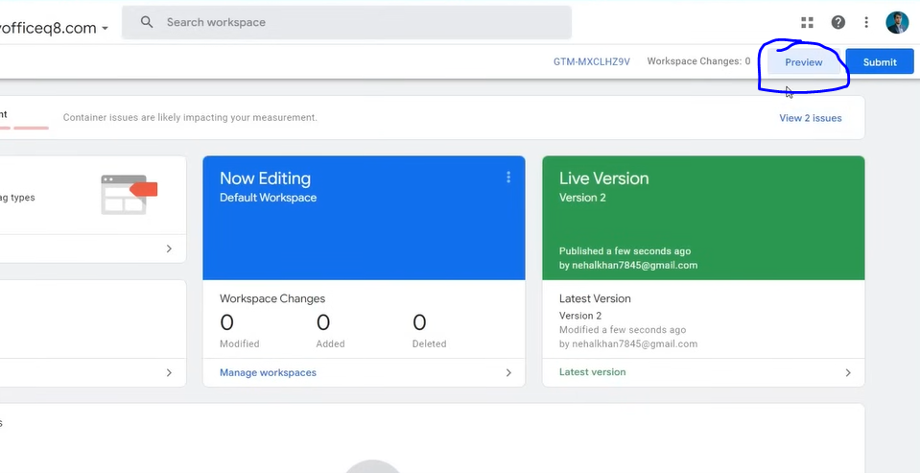

For that click on Preview as marked above

NOw we will perform all the conversion tracking and see is it working or getting fired or not

Also make your website connected ot the google ads as studied before

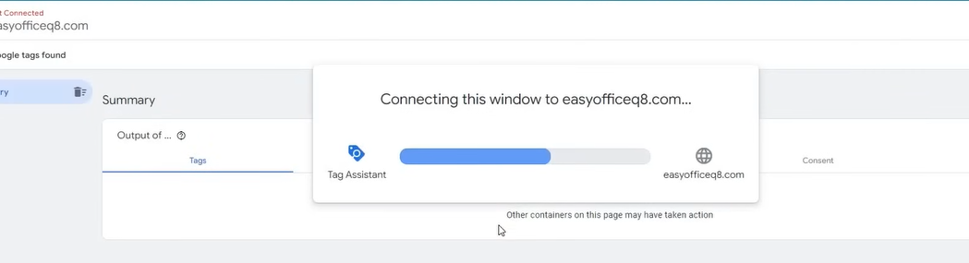

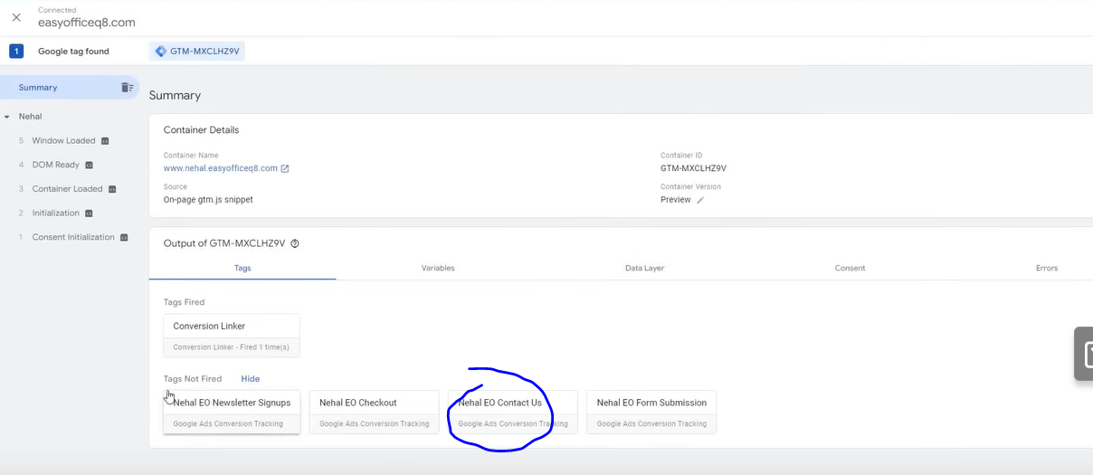

Now we can see all our made tag as shown above

Now they are divided into fired and not fired

If after doing the action in the website required to get it fired then the bx will go from not fired to fired

If it does not happen then there is error then we will diagnose it

Suppose we check Contact us and it is under Nor fired category as marked above

We do contact us action now below you can see it has come under fired

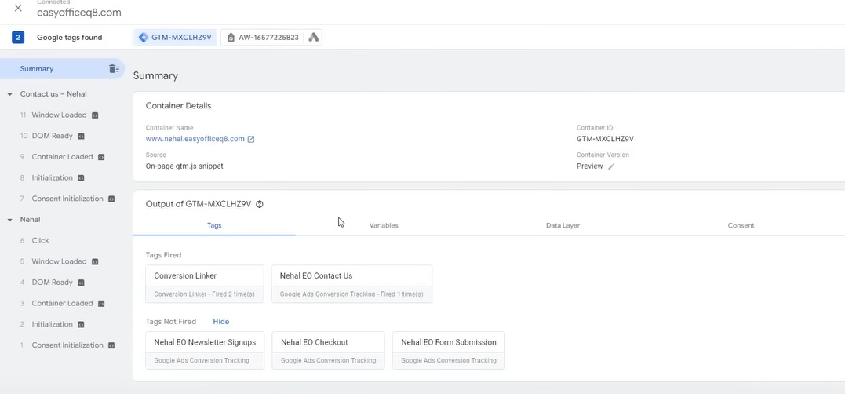

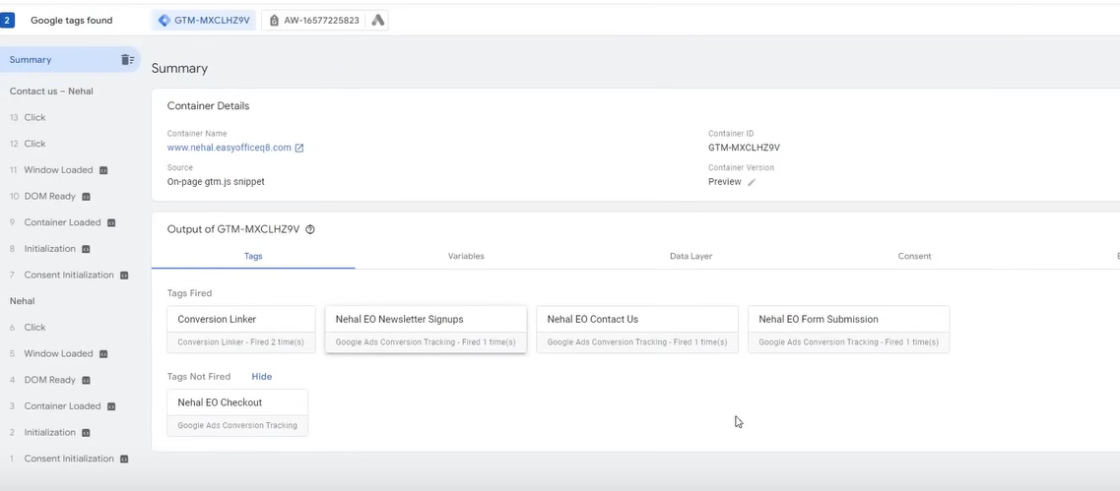

Now in checkout the teacher get the error because it is not going to triggered from not triggered

NOw to correct he go to trigger and then change the url comfiguration from conatais to equal of a url

Because problem arised due to path (I don’t know)

Now Publish the changes and then agaion connect to the wesite and then preview it

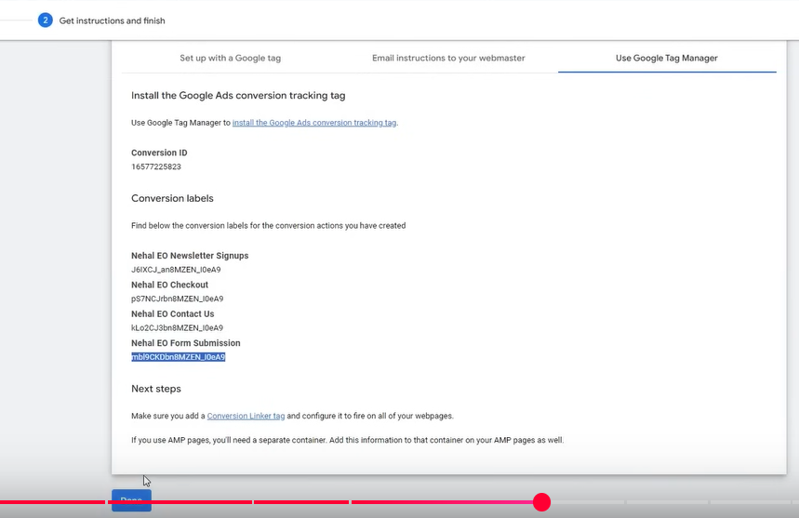

Now Go back to Google manager

And click on Done button   
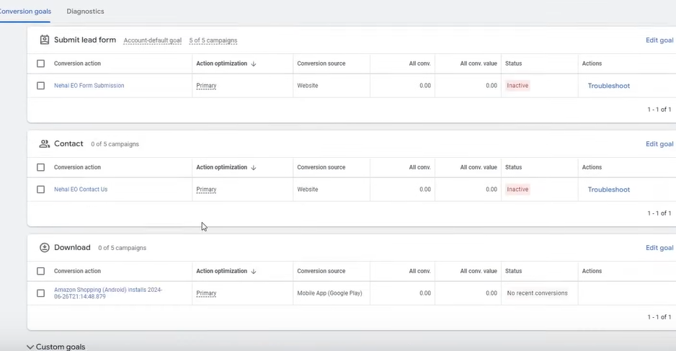

Now you can see all you r tracking in google ads

it is showing inactive so we reload your page

Now below will be shown

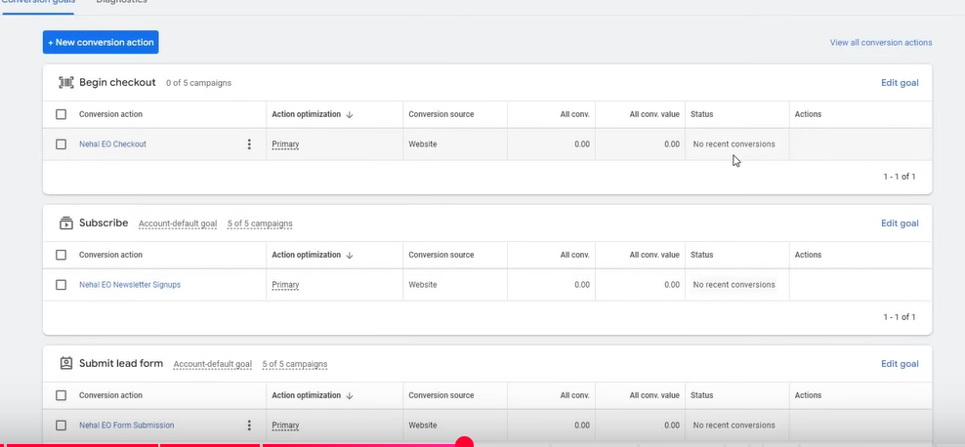

NOw you can see in each of the box no conversion is written because whatever action we permed till now was done in testing phase

Now if some one do conversion action then its count will be shown there

You can choose convergence as a primary convergence

TO choose a convergence as a primary convergence so that google ads can optimize on the basis of that conversion (showing ad to people which have high chances of doing that convergence action according ot their past )

Click on its respective edit goal option as marked below

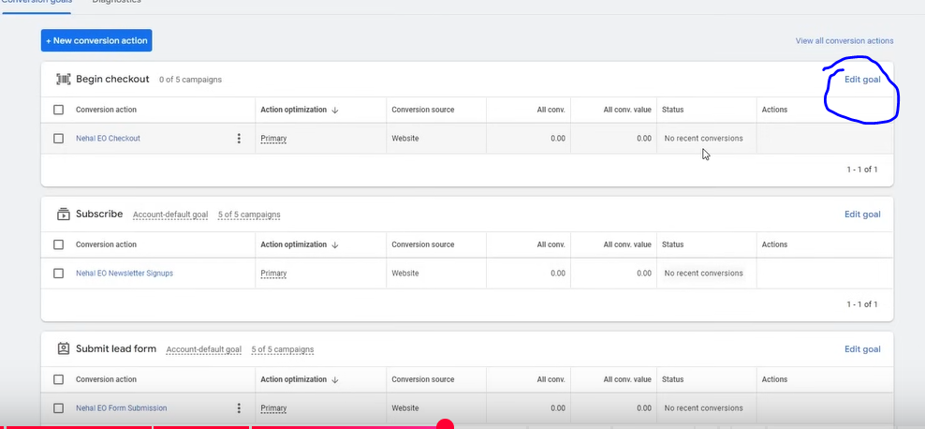

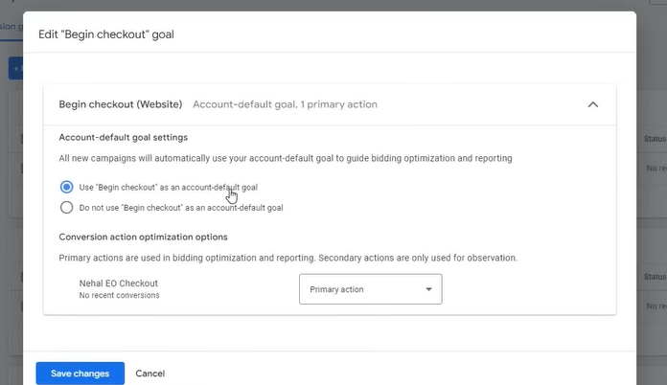

NOw a window will open like above Do the above configuration and then click on save changes

And choose all other configuration action as secondary

NOw our next gol will be how to addd dynamic tracking and how to track revenue and ecommerce tracking

**Phase 25**

**Lesson 10:-**

In this lesson we will learn about **Conversion tracking (Part 2)**

Now we will see how to track revenue

Now to do that we have a necessary plugin in wordpress that is GTM4wp

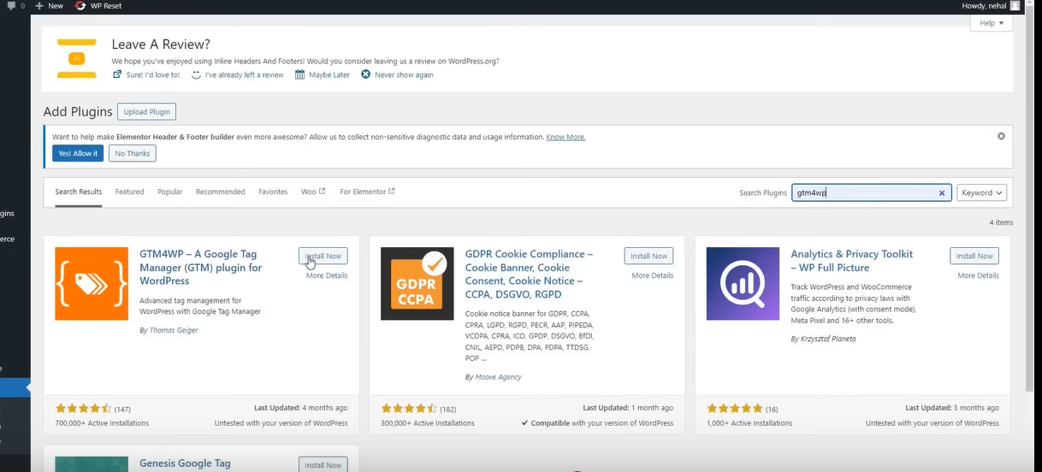

Install and activate the first plugin you see above

This plugin enable many data layer variable(who knows)

WE will do something in it setting due to which its data layer variable will be enabled

Its means that all the ecommerce convergence(listed below) normally does not come

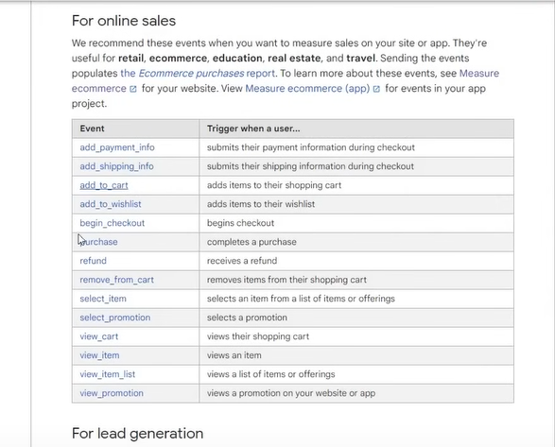

Normally you do conversion tracking you will not see this events

You have to osh it manually in data layer or there is a method shown by the teacher where we do all our work automatically through a plugin These data layer variable need to be pushed so that we can add value tracking on it and we can track revenue in ecommerce

Now we go to its setting

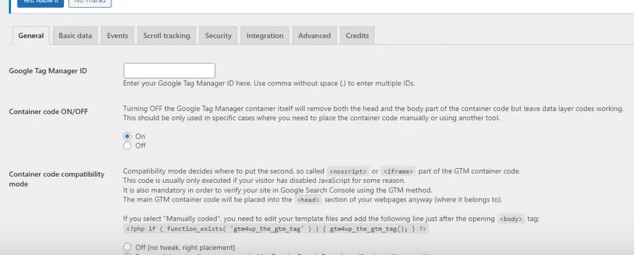

Now in first field you set your Google tag manager ID (as shown in below where the poiinter is)

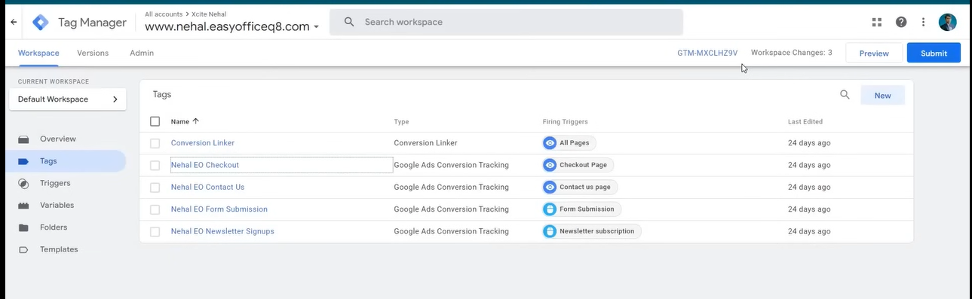

Now in container code On or Off choose Off

Because by on we are saying add the code of gtm automatically and this plugin automatic featurr does not work properly

So we choose off

NOw click on save changes

Now to get the code for gtm

GO to Google tag manager and then go to admin tab

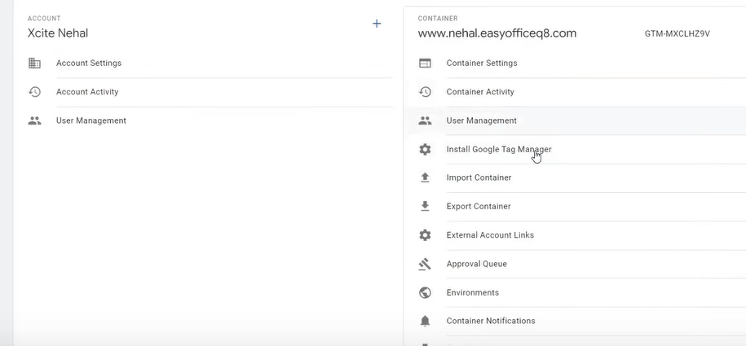

Then in side menu go to Install Google Tag Manager

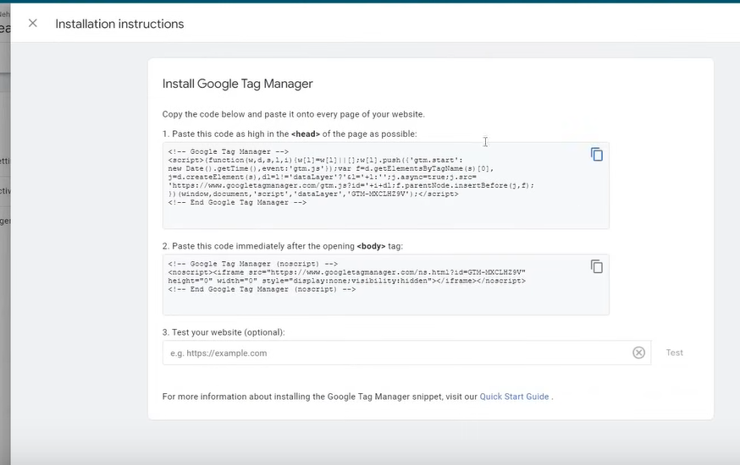

NOw add the code to the header and then to footer

Now we need to do additional step in setting of plugin we installed through whihch we can enable ecommerce tracking

So we go back to the GTM plugin

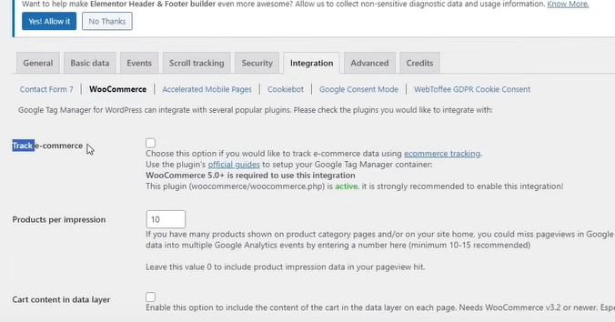

SO now we go to Inegration

And then to Woocommerce

And the check the checkbox Track e-commerce

Through this our data layer varibal will be pushed in our google tag manager and then click on save changes at the bottom

So below are the ecommerce variables that get pushed through it

Now we go to our google Tag manager an then reload it

And then preview it

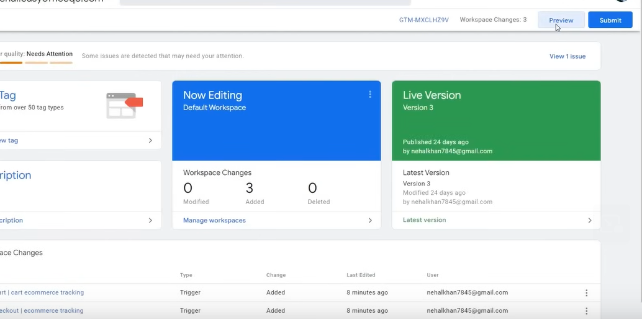

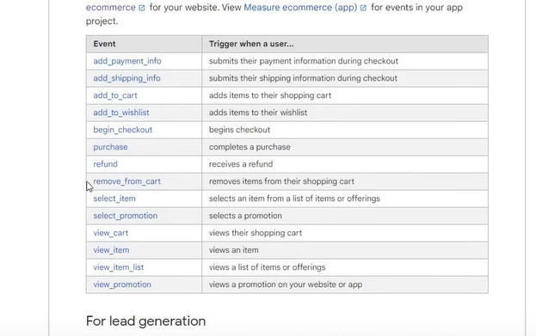

Now connect it

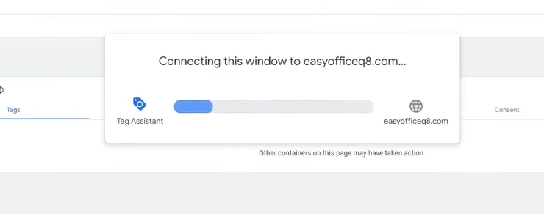

NOw we perform action in our w commerce ebsite that is add to cart

SO we can chck in summary that what varibales are being pushed

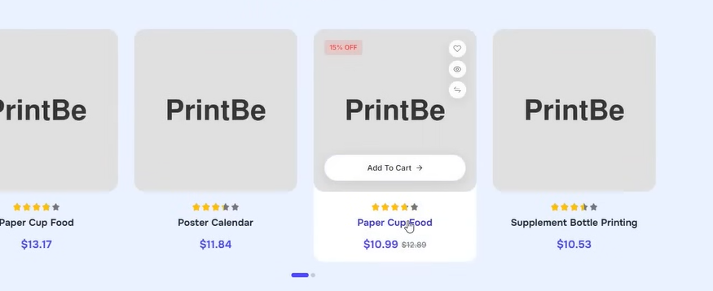

We add to cart

You can see all your action in the summary

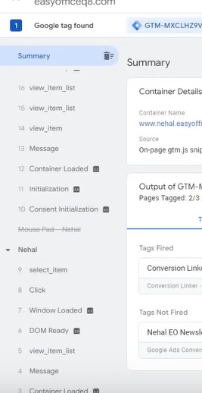 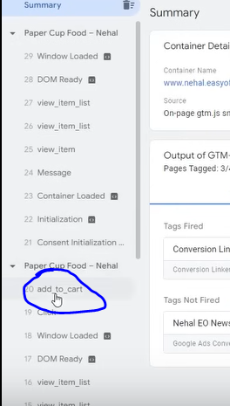

We can see add to cart in summary as marked above

If you view your cart then you will see there view cart also

SO you can add tracking in your event according to you

We will out it in add to cart or begin purchase

We are getting error in checkout since we have a demo site (I don’t know)

I don’t lnoe what teacher is doing

Now we make a trigger according to the events we know

The data layer is pushing the data

SO we make a trigger

It is easier than previous tracking

Since we are trcling event we choose custom event

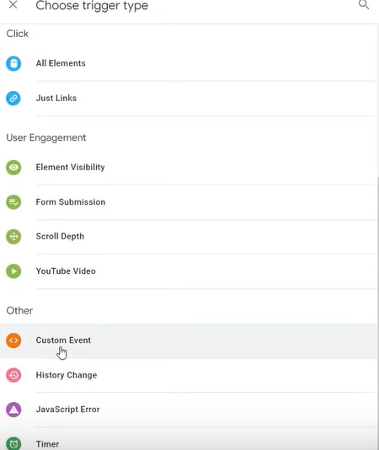

We will add tracking on the important eent like checkout

The way event is written in summary and the In event list of ecommerce we see above

Write the event nema in the same way so that our event will be properly pushwed

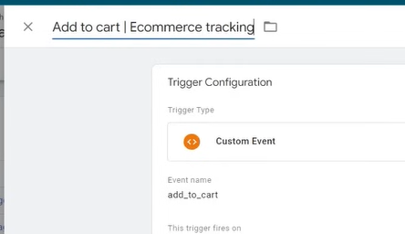

We name it as shown above

Now we save it

We do the same for checkout

Like previously we used track a thing by its value now we dno’t do it

Here we have prebuilt event that we can track by targeting

Now we go to our google ads account and there we make our conversion tracking and from here we create tags by doing conversion action

WE follow all the same steps as studies before conversion action

And in value we don’t chose a value because we don’t have any benefit on doing it in add to cart

If you want you can do it but it is not recommended

**Phase 26**

Now for Count wr choose every and now click on done

Now also we do for checkout

Now we do for purchase and now in value we do for different value for each

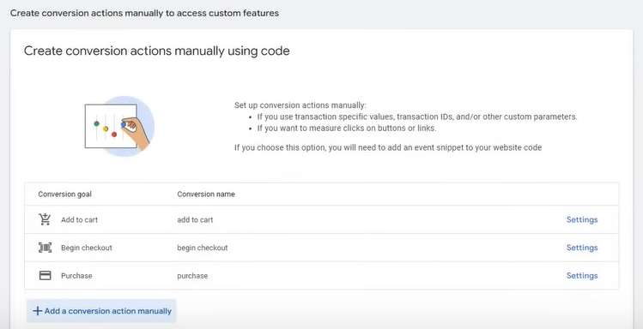

Now we have three manual conversion action

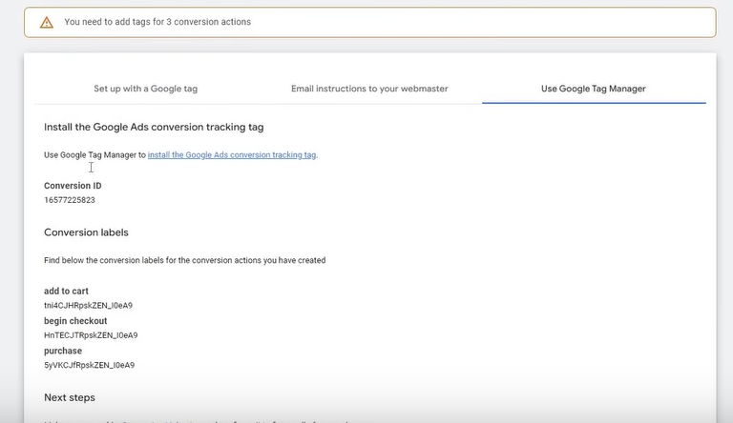

Now we have their labels

And now we will add their tag

Previoisly in your data layer you could only see basic information but now after plugin you can see mre detailed information as shown below

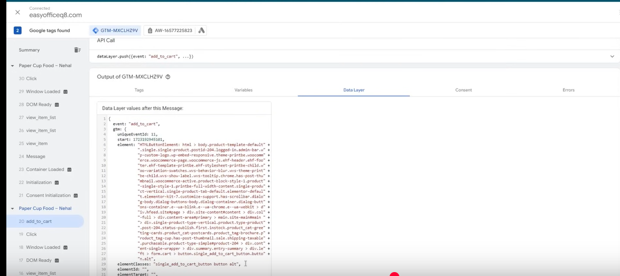

These all things are imported in our google ads

Means we could not see all these things

WE teach you this to tell you can important anything we want

Now we preview it and test it that whether it is working or not

You can see now out tags are listed as shoen below

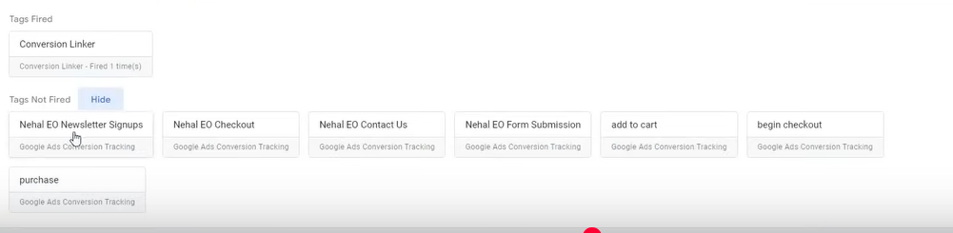

**Note:-**

Never forget to publish your tags changes in your google tag manager

Now suppose we click on add to cart of a product

Now you will see the add to cart tag will be found in the fired section as shown below

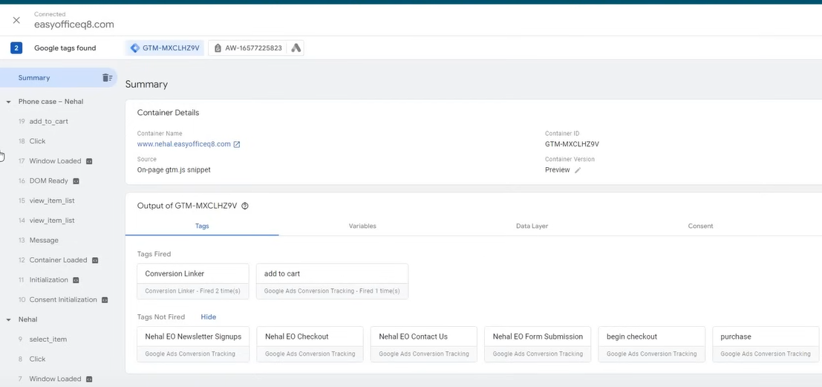

We could not do checkout may be because there is problem in our code of checkout

This will work perfectly if yi have allowed the method perfectly ans there is no flaw I our website

You need to make sure that ther must be one primary conversion in our case that is purchase

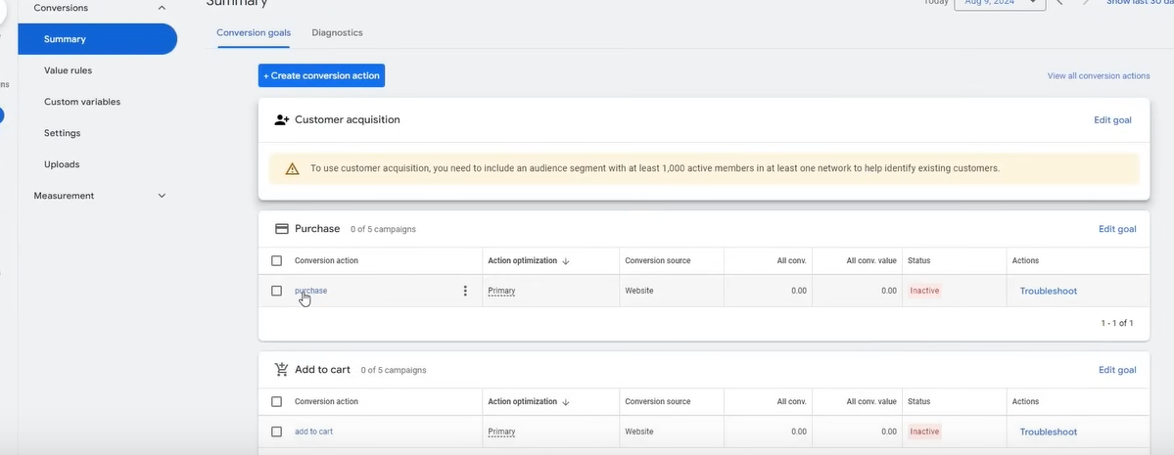

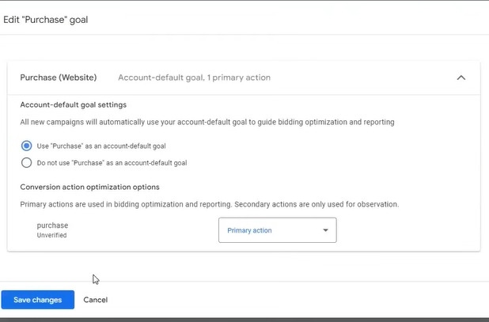

And it should be set as an account default goal

Some people say that conversion is just a way to track something

Basically your performance is decided on the basis of yor convergence

Because google ads transitioned because now More than manual thing automatic things are running Conversion tracking paly such a major role that your account cannot be scaled and it will be stuck

And Because of conversion tracking there will be so many problems we will face you will say convergence is not happening Its main reason is that you are not tracking your convergence and are not utilizing your due to which you are stuck in one place

SO make sure do conversion tracking in your account

Now Teacher has tough us two methods

**Phase 27**

First is button click or pageView

And teacher has also tough how to track dynamic value

Noe teacher will tell us in shopify how you do ecommerce tracking with revenue or values

So this is our Next topic

**Lesson 11:-**

4:40:22

In this lesson we will learn about **Conversion Tracking Part 3**

I will not do it as Wordpress and Shopify serves the same purpose so we will skip it and will do later

**So it is same like woocommerce n wordpress**

Yes, Shopify, WooCommerce, and WordPress all serve similar purposes—helping people build and manage online stores—but they are different in several key ways. Let me break it down:

**Shopify**

* **Fully hosted solution**: Shopify is a cloud-based, fully hosted platform. This means you don’t need to worry about web hosting, security, or server maintenance. Everything is managed for you.
* **Ease of use**: Shopify is known for being very user-friendly. You don’t need to worry about coding or complex technical setup. It’s great for people who want to get their store up and running quickly.
* **Pricing**: Shopify comes with a monthly subscription fee that covers everything (hosting, security, etc.).
* **Limited customization**: While Shopify offers plenty of templates and customization options, it has some limitations compared to WordPress when it comes to flexibility, especially if you're looking to do very custom or advanced changes.

**WooCommerce (on WordPress)**

* **Self-hosted**: WooCommerce is a plugin for WordPress, so you need to have your own hosting and domain to set it up. You are responsible for managing your website’s hosting, security, and maintenance.
* **Flexibility**: WooCommerce offers a lot more flexibility compared to Shopify. You can fully customize your website, themes, and functionality using plugins, custom code, and themes. It’s great if you want complete control.
* **Cost structure**: The WooCommerce plugin is free, but you will still need to pay for web hosting, domain registration, themes, and premium plugins. It can be cheaper or more expensive than Shopify depending on how much you invest in extra features.
* **Complexity**: While WordPress itself is relatively easy to use, WooCommerce requires more setup, and you'll likely need some technical knowledge for tasks like integrating payment gateways or customizing your store.

**Key Differences**

* **Ease of Use**: Shopify is more beginner-friendly because it’s a fully managed service, while WooCommerce gives you more control but requires more setup and maintenance.
* **Customization**: WooCommerce, built on WordPress, gives you more customization and flexibility, while Shopify is more streamlined but offers less flexibility in terms of customization.
* **Costs**: Shopify has a fixed monthly cost, while WooCommerce might have lower upfront costs but could require you to spend more on hosting, plugins, and themes depending on your needs.

In short, Shopify is great for those who want a hassle-free experience, while WooCommerce offers more flexibility for those who want to build a completely customized site.

SO to do add tracking in shopify we will follow the below doc by double clicking on the below image



**Phase 28**

**Phase 29**

Now we will see further campaigns

5:02:43

Lesson 12:-

In this lesson we will learn about **Dynamic Search Ads**

Till now we have understood that how to create ads word account ,ad geoup , how to do keyword research

How ad copies wil be fornwd we have understood till now , ad extension and campaign setting

We have made seach campaign now we need to make further campaign like

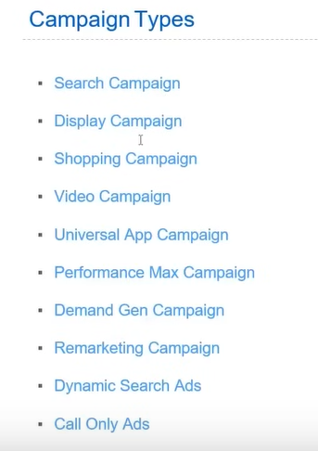

We need to see other campagn as shown above

Which teacher already has understood

Like in search campaign there was many things like budget , location etc

We will not ino there detail butwhat teacher has not told until now

NOw we study **Dynamic search campaign.**We will not follow above list in order because some campaign may take time but the campaign that can happen early we can do it then we can go to longer campaign

The dynamic short form is dsa

How It is different from normal or standard search ad we will make you understand

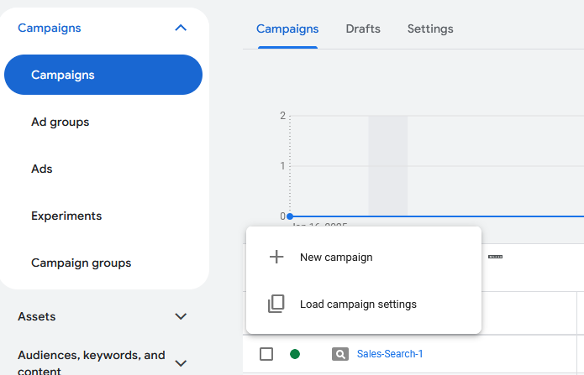

NOw we will go to new campaign

And choose our objective our is sale so we choose sales

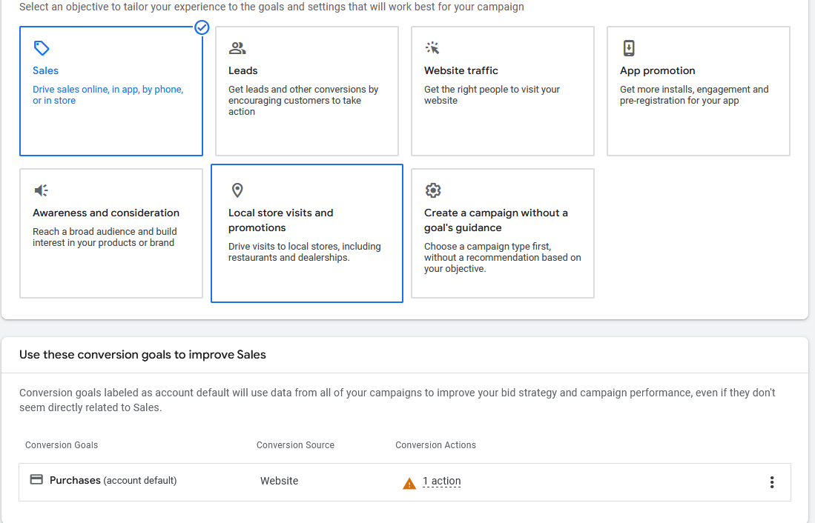

Click on continue

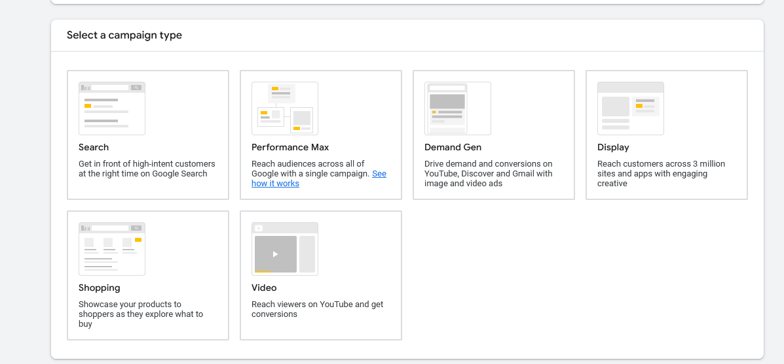

Now click on Search in campaign type

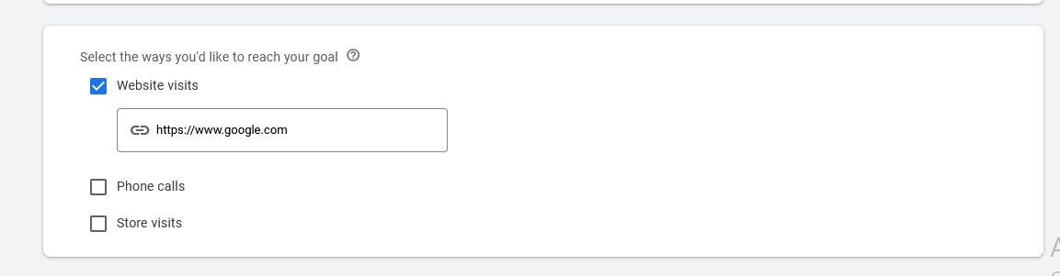

Now choose Website visits and then in the field type the url

Method is almost same but in last we will do slight changes

Click on continue

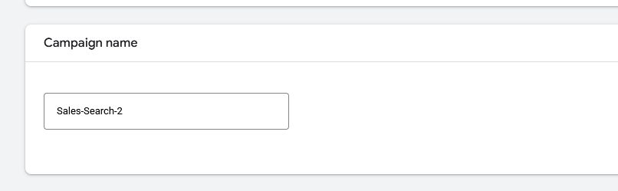

Tell about the campaign name

Click on continue

Now comes the bidding strategy Teacher has alrweady told us about it but bidding strategy that needs to be told I remains

Which we will tell you now

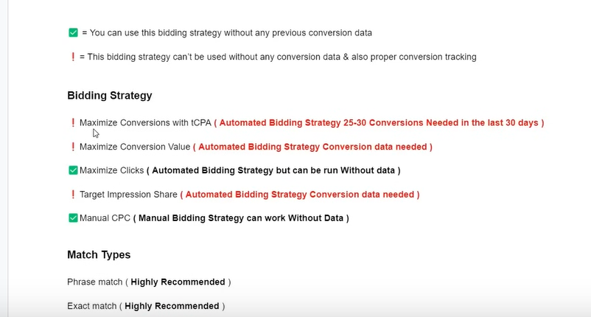

The green tick means you can use this bidding strategy without any previous data

And red tick mark means using this bidding strategy without any previous data is risky and the chances of occurance of result is almost zero

First in Bidding strategy we understand

Maximize Conversion with target CPA

In this you need 25 to 30 conversion needed in 30 days

And then in Maximize Conversion value Previos data is needed

If you have an imporessive data then it is good

Now comes the Maxiumize Click you can run it without data

Its side effect is it optimize on the basis of clicks

It tries to bring clicks as muh as possible in which there is danger that low quality click also come there which does not have value for you that click and you have to pay for that click

So teacher rarely use it

Next is target impression share

This bidding strategy is barely used

Its problem is that google will try that you ad should take high impression share

Google will not se e that your conversion are coming or not

Google will only see that your ad should be shown in the top

**Impression share is the percentage of times your ad is shown compared to the total number of times it could be shown**

And the impression share we demanded we should get that impression share

DO is bad side is that getting conversion is very difficult

Measn you pay for something you does converge has no benefit

Net is Manual bidding strategy which you can run without data

There are two option in it first is

Enhance with conversion

And another enhance with conversion value

Whenever you create a new ad account or new campaong then choose manual cpc without any

Enhanced tick

In conversion setting you can see in in Bidding that manual CPC is chosen

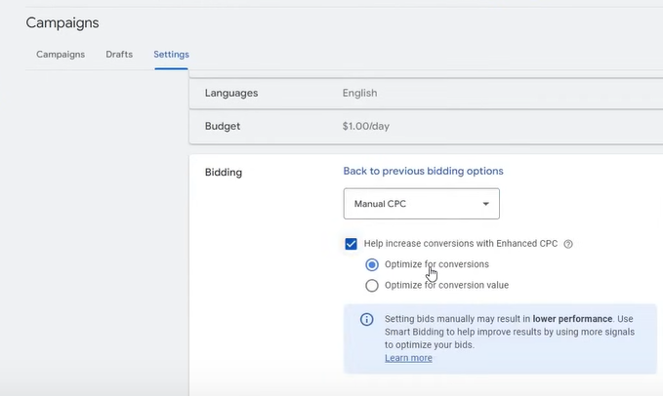

We uncheck the checkbox if we are running it first time we don’t get any advantage here because it don’t have any data and you run it then it will still work

But after 10-15 days

**Phase 30**

You have good convergence then you can check it

If it you have choosen lead generation in campaign type then you can choose convergence

Or if it is ecommerce then choose convergence value but make sure both the things are being tracked on the basis which you are trying to optimize

The main issue of automatic bidding strategy is that your tracking should be good and what you are tracking that should be convergence accurate data and on the basis of that it will optimize your data

It has benefits as it take many decision in real time which is manuaaly impossible there are some problems but the way the teacher has tough us convergence tracking if you do it then you will not have any issue

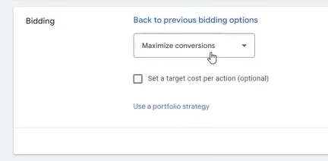

Normally what people do is that they see the maximize cinversio ans theythink maimuim convergence will come

But it is not like that if you put max convergence like that then what happenes is that without data it will od aggressive bidding whoc lead to loss and cost will be spent and you will not get convergence as well

So the better will be run the campaign sometimes in manual CPC

And by keyword research what bid you need to keep and then we switch to any automatic bid strategy

Teacher recommends that remove target impression share and max click from you list

If you need to use maximum convergence then use it with target

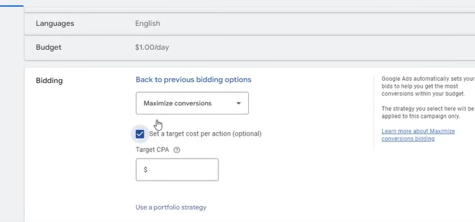

Without target ther will be very aggressive bidding

For examplr in last 30 days you do manual CPC there you are getting cost er convergence then the teacher give us 24 dollar target CPC

Now it get extra space for optimize and your convergence CPA will be lower than 20 dollars(who knows I don’t know)

Max convergence is used for Lead generation and ecommerce and Max Convergence value is used for Ecommerce

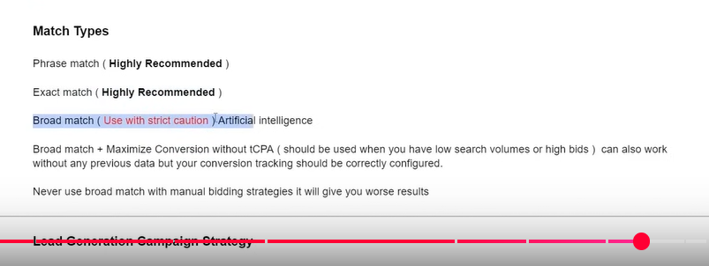

Now in Match types Phrase match and exact match , Phrase Match is recommended but Broad Match is not recommended and should be used with caution. The benefit of Broad match is that it uses Google AI and signals and in real time take lots of decision

Many people will say not to use it

But it is such strategy that you can get convergence from it

There are some problems but there are other benefits

So it will be good if you use Broad Match with Maximize convergence without target CPA

So don’t use Broead match with other bdding strategy

Use automated there is no benefit of using it with manual CPC

It is like a wild card which we use when we have very less option

It should be used when the keyword you are finding you are not getting search volume and bids are very expensive the you incorporate this strategy yo will get good result here

You can lso work with previous data but your convergence tracking should be good

I am taking about Broad match

Never use broad mathc with manual bidding strategy it will give you worst result

If you want to go for manual then you can go for phrase match or exac martch that will work perfectly

Now in bidding click on next

And now we come in Campaign Settings

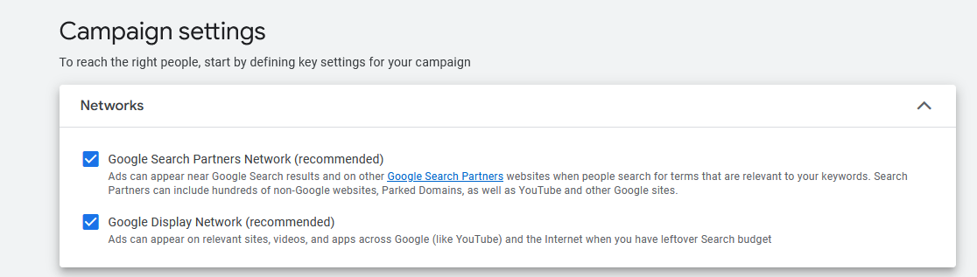

Now in Networks Teacher has already told us that first checkbox is such that you ad will be shown in other googel search engine partner or websites linked with google and second check box for showing yourad in Youtube or other google visual platform

Teacher recommends that alwas choose foirst checkbox for search ads

First option will not bee good for Indian subcontinent because google partners are mostly used on foreign countries

Sometimes we get good result and sometimes not

5:16:30

So you can use it fir testing When teacher will teach us about optimization topic that after selecting and running your campaign then after running how to analyse your data that how much cinversio is coming from search partners and how many we are getting conversion from Google so that you can bring some changes

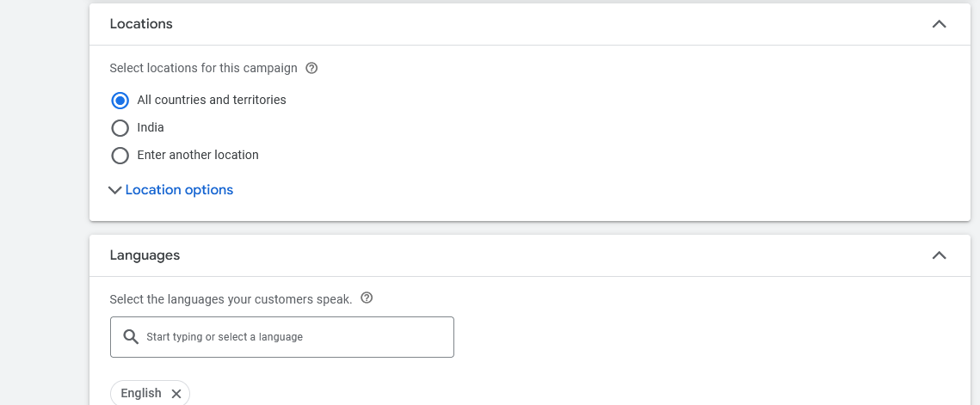

Now we choose location and languages

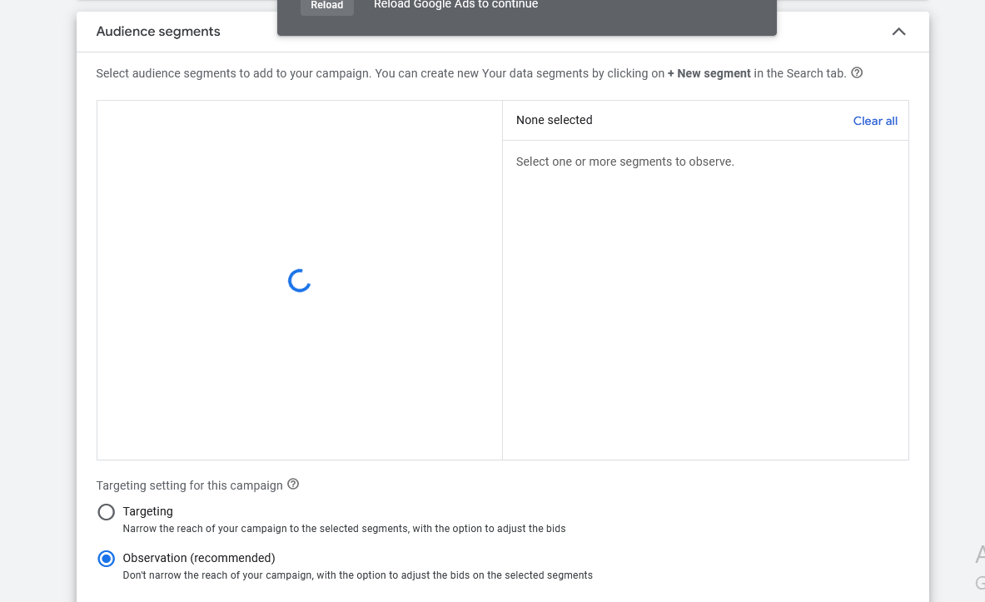

We have already dixcussed Auience segments

We make the audience in observation as shown abive(who knows)

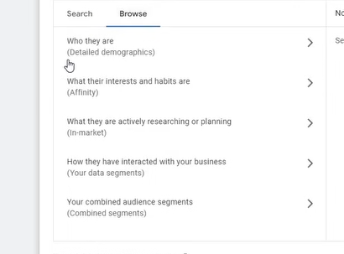

We go in browse then

IN detailed demograohics

They are enhanced version of Demograohics It includes below things

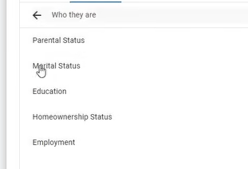

Affinity is related t interest targeting and in market are thise audience whi are frequently serarching for something

You can have your own data segment

And combined data segement is not in use(I don’t know)

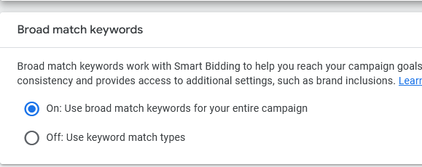

Keep the broad match keywords off

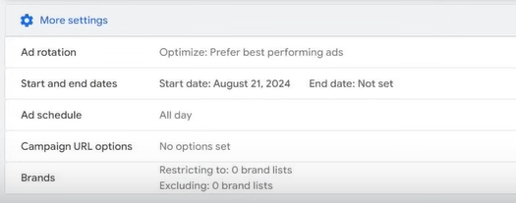

Previously on above there was an option for dynamic search ads but in recent updates it has been removed

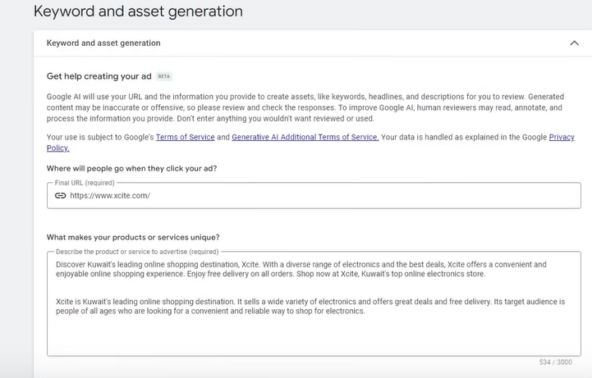

Now in keyword and asset generation

NOw we just create a normal compaign with sie random data

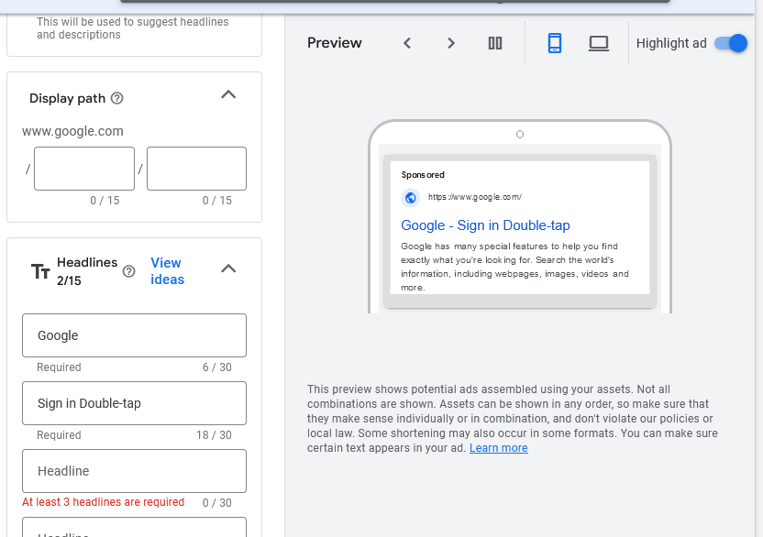

NOw click on next

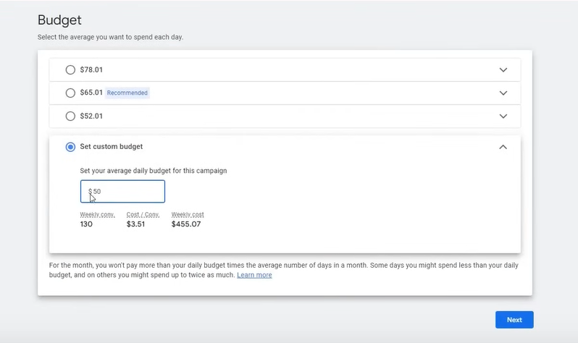

Now in budget

Teacher has said that idf you are setting it cost then its doeble can be spent means 100 dollar per day but if you think it from a month point of view then it will not go abive 1500 dollars

NOw teacher will publish and we will be shown how dsa is formed

Previously it was used to found in the campaigns

NOw we hve to use diiffferenet way so that we can reach dsa

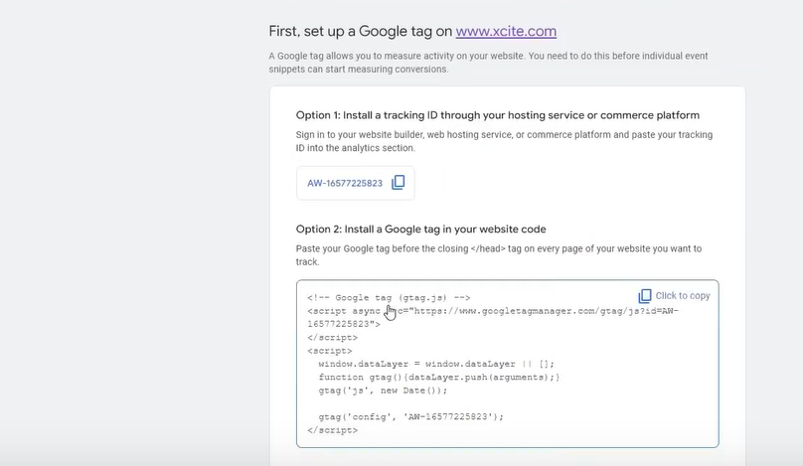

Now it is saying to add google tracking

We have already done this

It not giving us ioti ti go back so we click on cross

Now after adding the campaign try to filter the camoaign list to find your camapaign you made(whi knows)

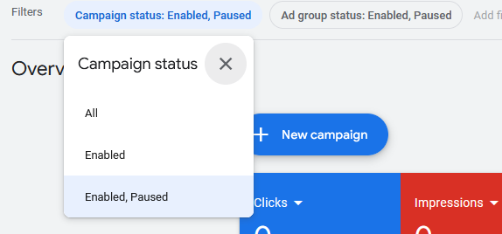

You can filter the list by campaign and ad group status whether it is enabled or enabled ,pause

SO we have made a random data campaign

**Phase 31**

We go inside a cmapign by clicking on it

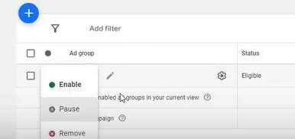

So by above way we can set the status of the campaign or adgroup

NOw you will reach the ad group list

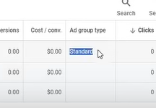

Now in ad group type column standard is written x

We need to make our ad group dynamic

So for that click on + of the ag group

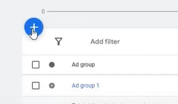

As shown above

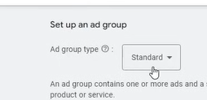

Now set this to dynamic from standard

Now a prompt will ocme cliuck on continur button

NOw it has become dynamic

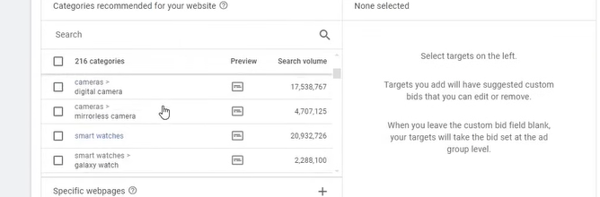

IN abve it will give the categories according to the website you give and laso givr their respected search volume if a structure is formed by SCO (whi knows) and you ca n run your dynamic search ad there

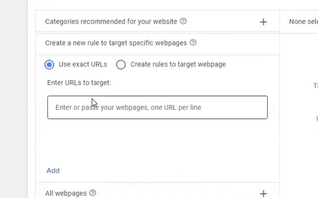

Or we can give the link of a specific website and can run on ads on it

After pasting the url click on add to add the url

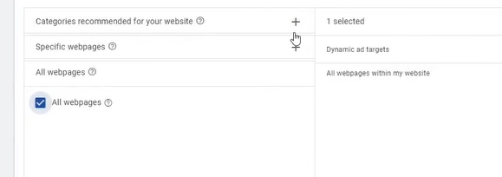

If you want to do for all pages then yu can check the all pages (who knows)

You need to go categorywise you need to make new ad group for laptop or new ad group for mobile

Measn you don’t have to put all the target in one ad group

If you did it then it will be very complex SO suppose we make an adgroup and name it Samsung then we choose the categories related to Samsung

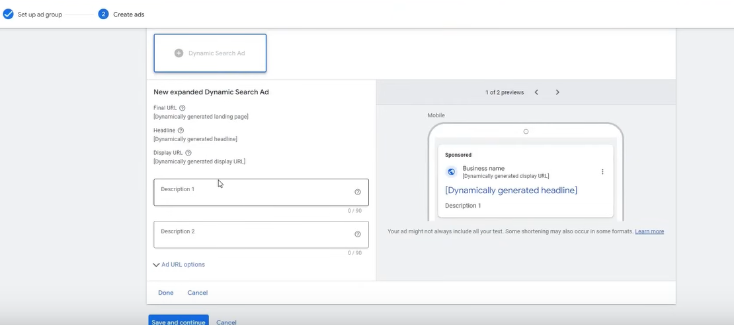

NOw create your dynamice multiple ad

Their Heaadline or url will be formed by the google

Google will read your website and the exactly relevant keywords and provide it

It can happen it ahows the peodycut to hteh user and he might purchase it

You just have to provide desctiption there

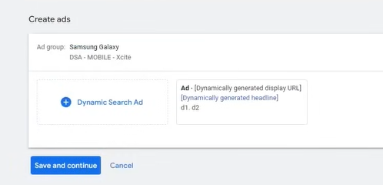

It is recommended to create three ad set

Now click on save and continue now our dyncmaic search ad is formed

IN this you don’t have to keyword

Google will automatically pick up keywords for demonstaration what keyword it will pick it we have seen in keyword plner by website url

You don’t have to workhard and it performs well fro what teacher has tested its performance is good

It is better than normal campaign

DSA is used for scaling

It will not happen that a campaign is perfuming adnnyou increase the budget and it starts working

At a certain budget it stiops working (I don’t know)

If it is performing in 50 dollars and if you make it 60 dollar it is not gurantee that it will woprk

Its busget cap is only50 dollars and it can give performance in it

So what we do is create multiple campaign so that we don’t have to increase the budget and we do scaling through number of campaign

The more campaign there will be the more conversion will happen if your conversion is made correct

You can also add anpther ad gourp in the campaign the procees is similar to dsa

**Lesson 13:-**

In this lesson we will learn about **Call only ads part one**

Now we will see how to create it

We will understand something related to it S

Before creating it you need to understand some things that it worked only on mobiles and ir does not run on desktop

It is such that your number is shown ad you click on it then your mobile dialpad will be opened with the number that’s why it is tht effective

These ads are of different variation like some have description and some have don’t

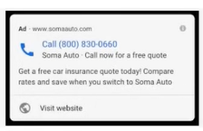

This call only ads is 2.5 – 3 times more expensive than normal search ads if it has some pro then there are also cons

If you have bid in your keyword planner and from low and high bid we find the average that is 5 dolar then we multiple it by 2.5, 3 or 2.7

If you have low budget then multpliy it by 2.5

If you do normal bid then impression clciks will not come you hve to bid high here It is its drawback

So we click on new campaign

In your Campaign objective choose sales

5:27:30  
In campaign type we choose search campaign

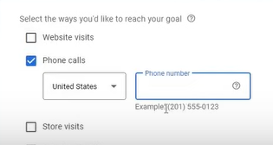

Nw in ways to reach your goal choose phone number instead of Website visits

And now click on continue

Now we name our campaign

And we have covered bidding strategy previously

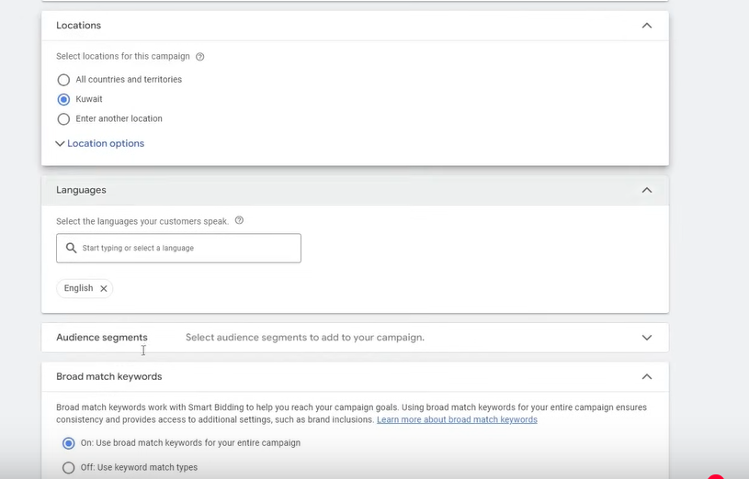

And we have covered above

Now we come in directly main part other things will be same the difference will be only in ad

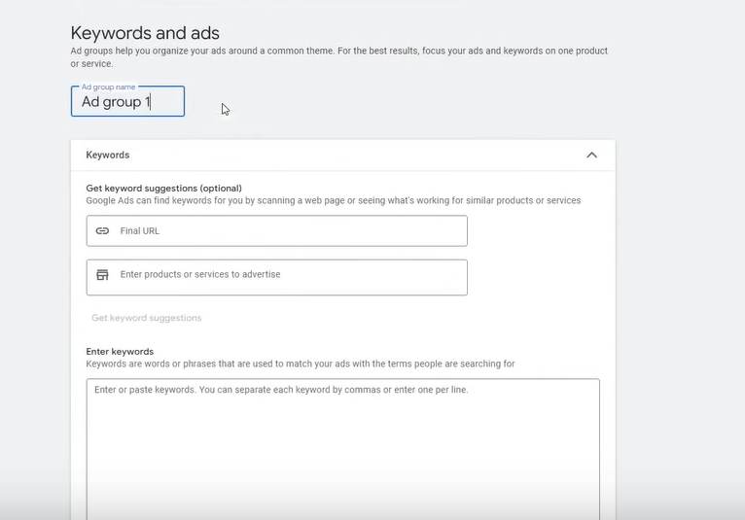

Now make the keyword nad name the ad group

Now we create ad as shown below

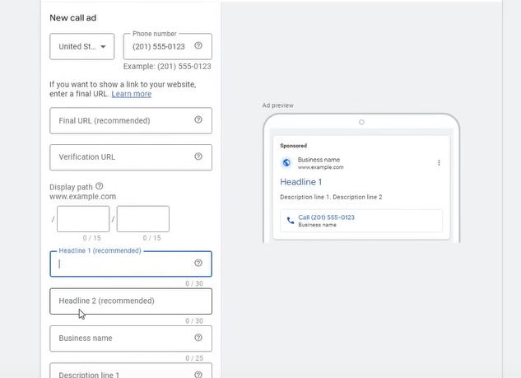

Off course it will not be used for ecommerce but for lead generation

We take an example of solar services

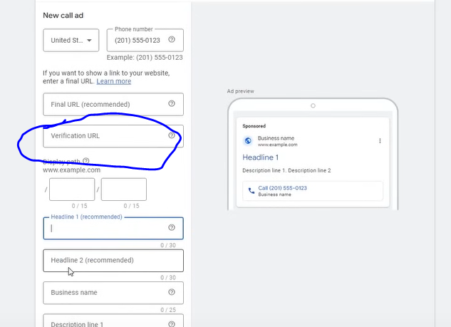

What is this erification url as marked above

The verification url is that the number given in above preview it should be present in the url ven in it so that google can verify it

It should not be like that for websites this is different and in ad it is different

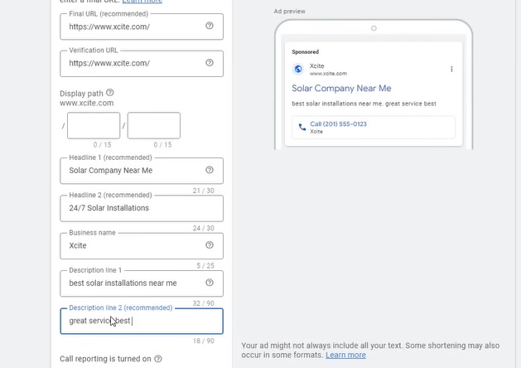

**Phase 32**

For this it is important that you make tracking

Like the teacher told incall extension that the call is important(I don’t know)

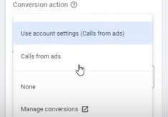

Now we select the conversion which you have added track0020

Now accept the terms and services

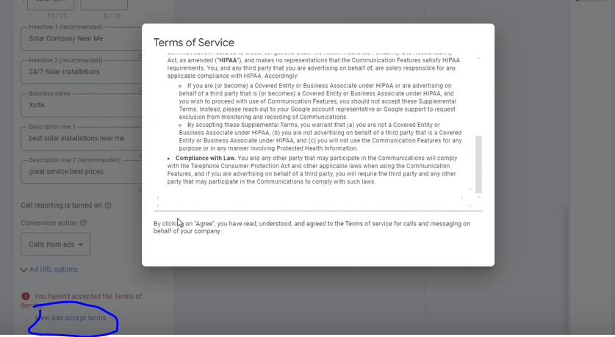

To see it click on marked above

**Lesson 14:-**

In this lesson we will learn about **Call Only ads Part 2**

Now click on done

**Concept**

Now the structure is like that s

In ecommerce it is categories but I lead generation it is services

SO in ecommerce categories are used as ad group and in lead services are used as ad group

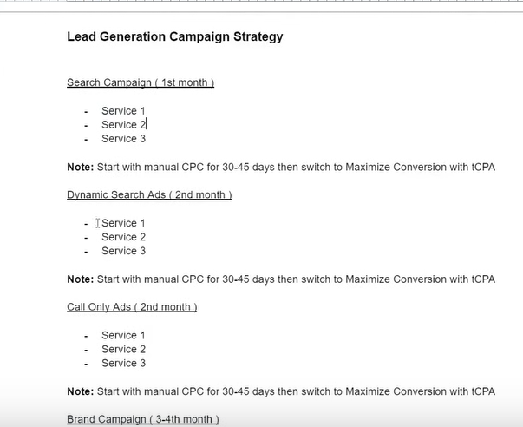

The above is the strategy

What happens Most of the call ads is that it is also done byu the teacher

That in one service there are three ads

Because teacher want that call only ads should run in separate budghet

If I put multiple services then budget will be utilized very less

Fter they are made then it will bepublished

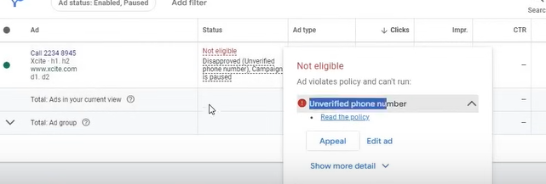

AD become disapproved because it is different from the url we gave

**Lesson 14:-**

In this lesson we will learn about **Universal App campaign**

This campaign is used in the cases where there is app in play store or in apple store you want to prompte it you want to bring installs in it For that you need to run ads

It is also called app promotional campaign

So create a new campaign

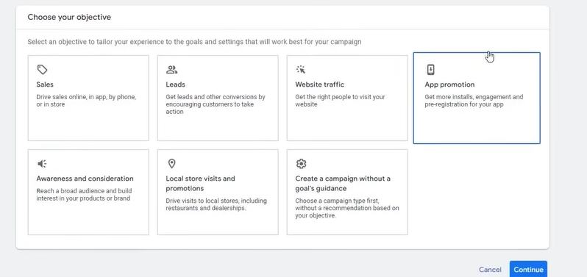

And now choose App promotion in campaign objective

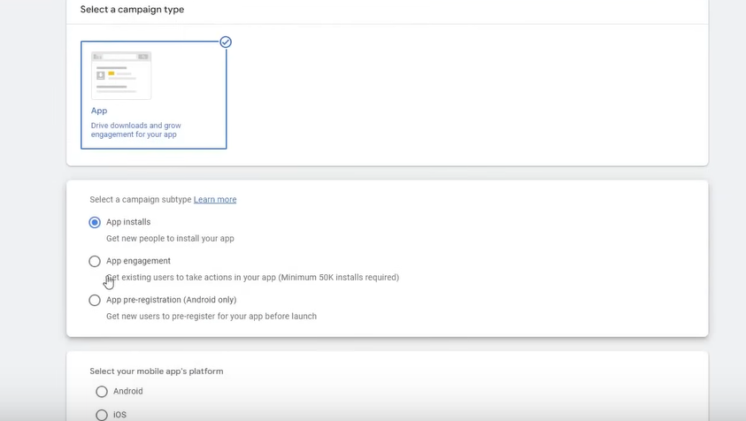

And now you have three campaign subtype that is that is App installs , App engagement, App pre-registration (Android only )

By app install we men we want more and more installs

And then in app engagememnt we want that they should install it and also enage with it

But it has requirement that there should be atleast 50k installs in our websites

SO that it has data and we can do it

In App preregisrate we promote app that are about to be launched here

App install is mostly used and App engagement Is rarely used

Now it will ask you platform like that is android or ios

Yiu cannot do bith you have to run separate campaign for anroid and separate for ios x

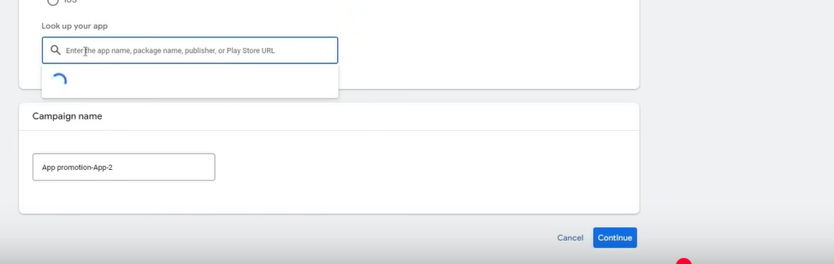

Now in lookup in find your app that you want to promote

Name the campaign and click on continue

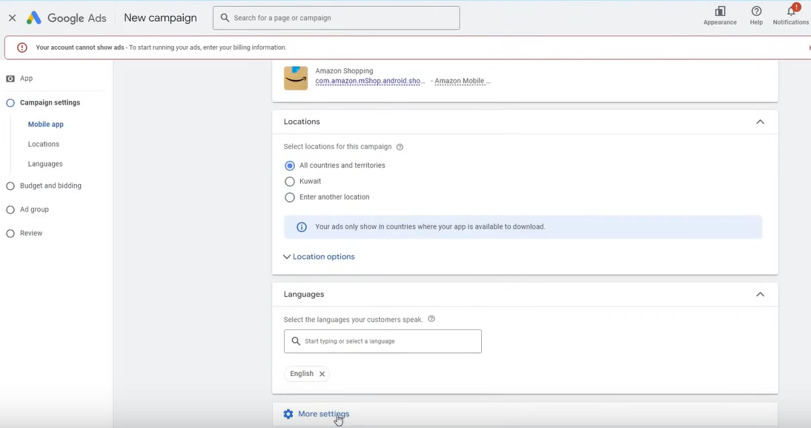

Now we come to campaign settting

We choose the country and languages

Click on next

NOw we come to budget and bidding

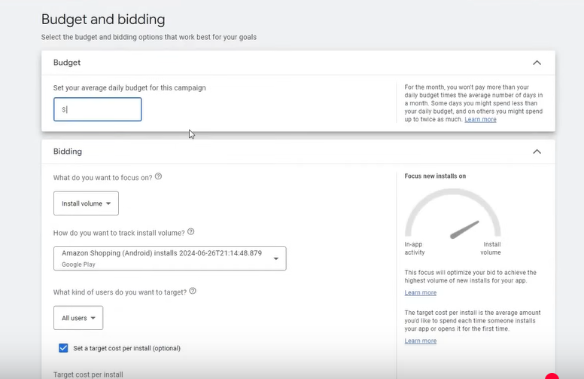

There some new things also

Now in bidding we choose Install volume

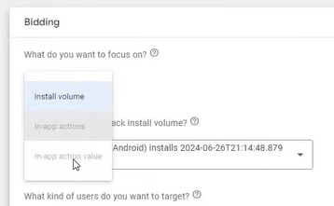

The other disabled option will be available if you have added tracking to youer application

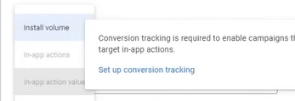

If you go to conversion tracking then you can know how to do it

Mostly people choose install volume

Our basic work is done here

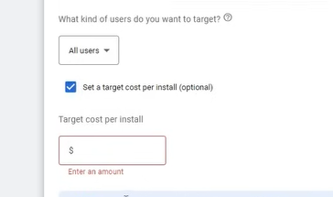

You can choose cost per install if you does not tell then it will be optimized automatically by google

Now we will in app purchase option by setting up a tracking

Now follow the steps below

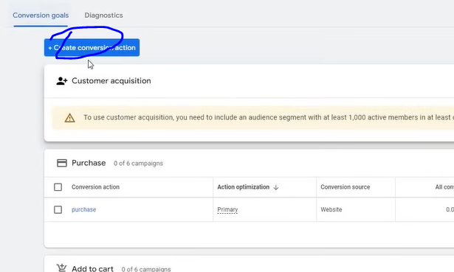

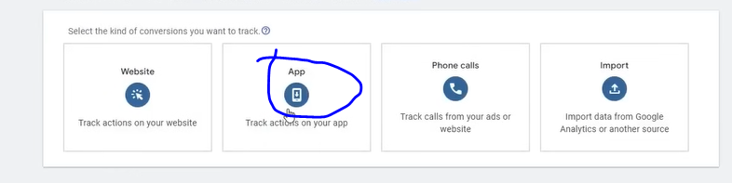

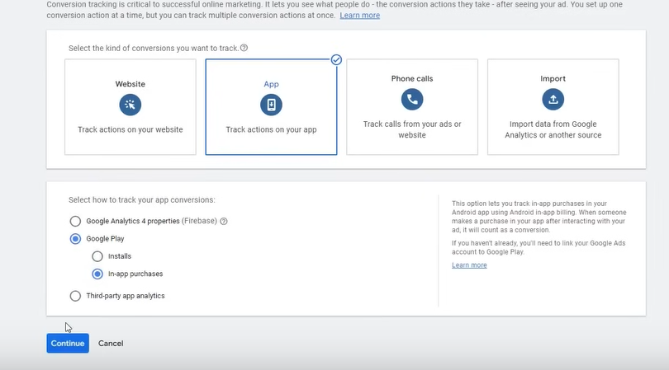

Firebase can be tell by a developer

It is separate

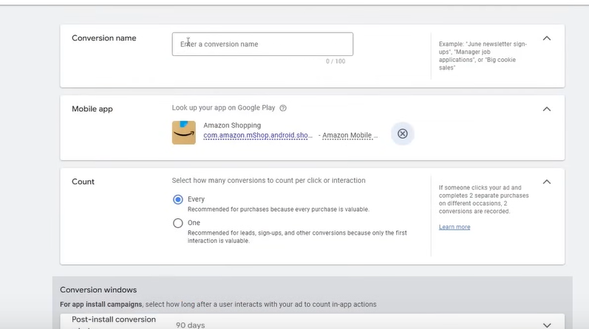

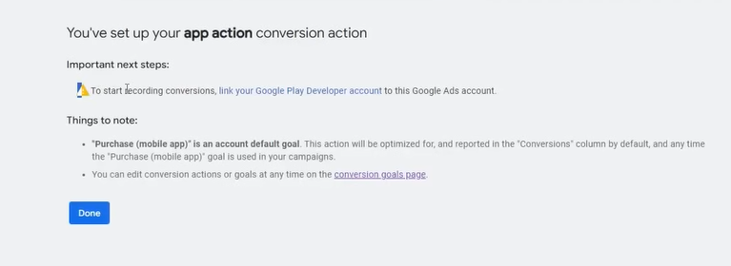

Now you have to do additional step that is you have to connect it to Google Play Developer account for conversion record then this tracking will start working

Now how to tack install volumes(I don’t know)

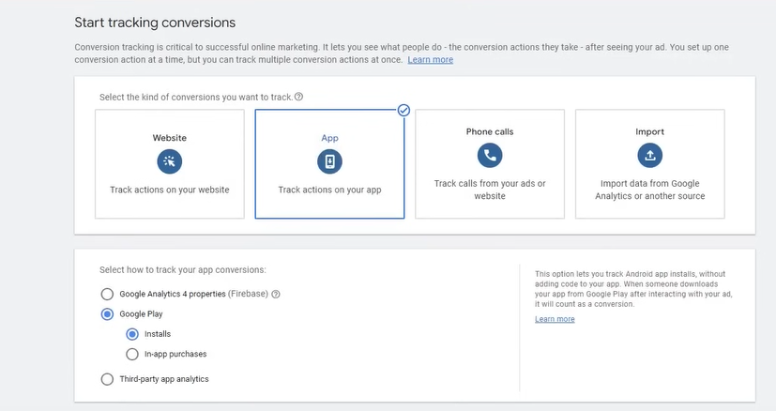

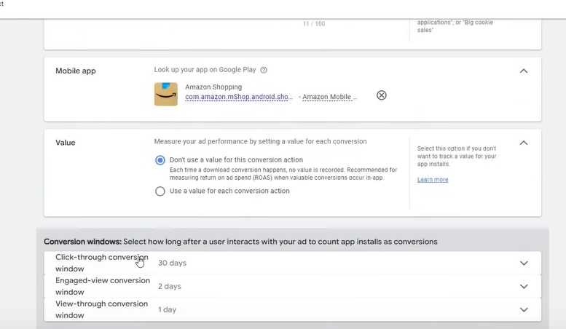

Now back to campaign making

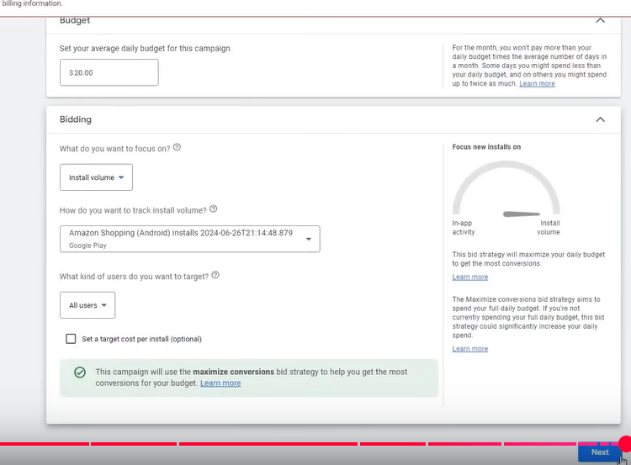

In most of the campaign ad group is same but ad might be different

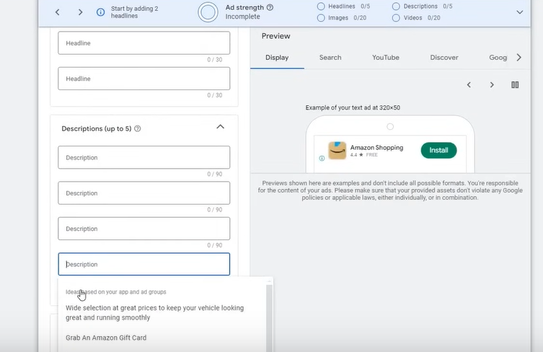

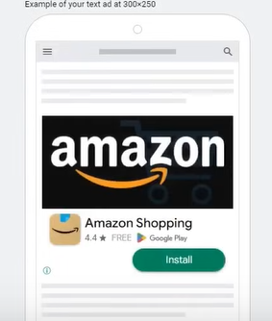

Above is the preview how your ad will be shown

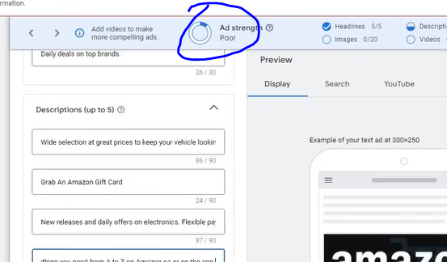

Ad strength is not important whether it is good or bad you should know that it is good

Some people optimize on the ad strength that they think if the ad strength is not good tehn the conversion will not be good

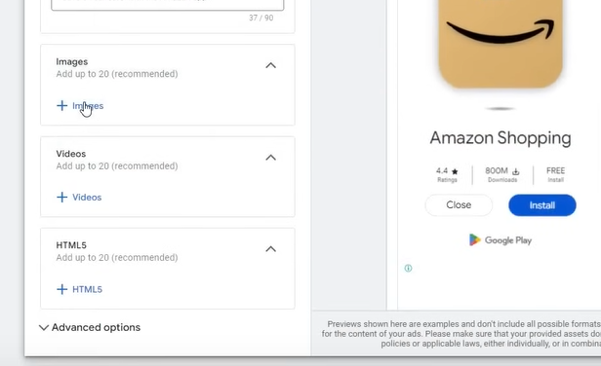

You can put images , videos or banners

Click on images

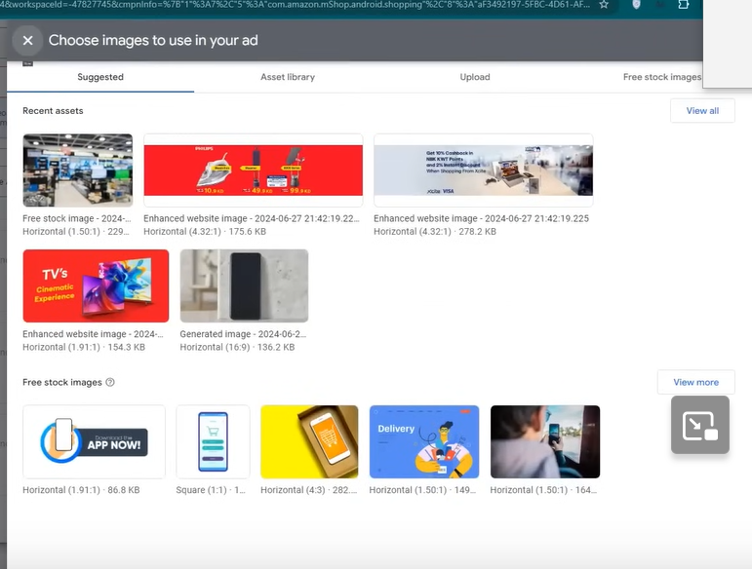

Click on question mark in above window to know the type of image we want

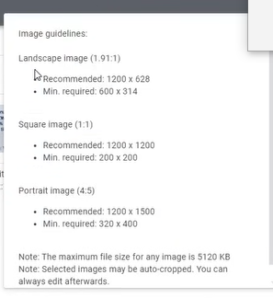

So you give this guideline to the developer and he will give you banner or design

Choose the image and click save button to upload it